|  |
| --- |
| Qatar University, Department of Computer Science and Engineering |
| GoodBuy |
| Web Development Fundamentals | CMPS 350 L52 |

|  |  |  |
| --- | --- | --- |
| ***STUDENT NAME (Group 3 –Section L51)*** | ***STUDENT QUID*** | ***STUDENT EMAIL*** |
| Ferial Mohamed Zakaria Awadalla Marzouk | 201706475 | [fm1706475@qu.edu.qa](mailto:fm1706475@qu.edu.qa) |
| Fatma Ali Elbakry Elbadrawy | 201901981 | [fe1901981@qu.edu.qa](mailto:fe1901981@qu.edu.qa) |
| Bshayer Rashid M A Al-Marri | 202007129 | [Ba2007129@qu.edu.qa](mailto:Ba2007129@qu.edu.qa) |

# **Github Link**

[Fatma-fe1901981/GoodBuy (github.com)](https://github.com/Fatma-fe1901981/GoodBuy)

# **Screenshots to Test Functionality**

### Use case 1

### Show that when a user cannot log in if the password and username does not match

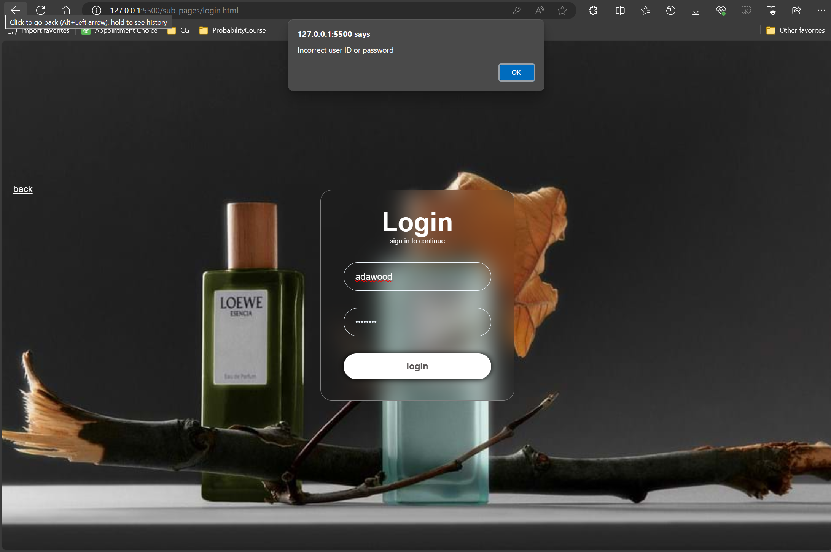

### Show that a user as a customer successfully logs in

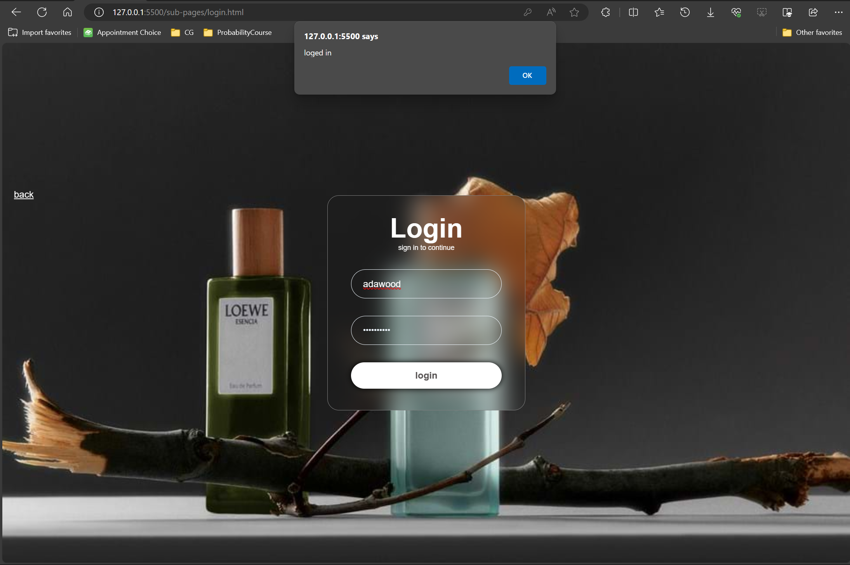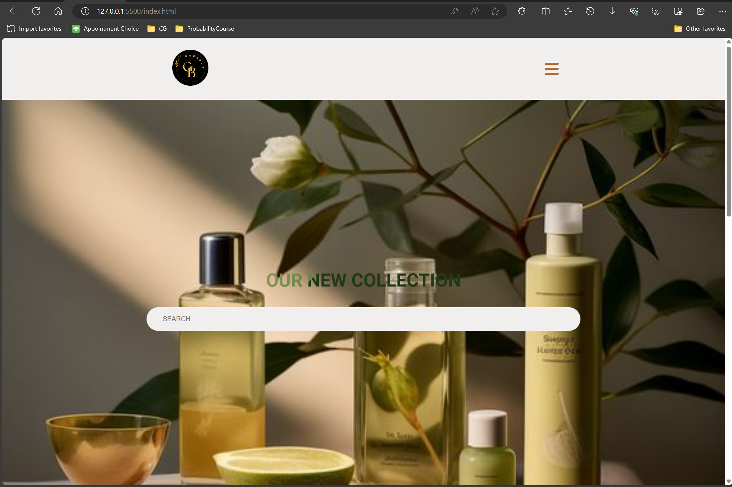

### Show that a user as a seller successfully logs in

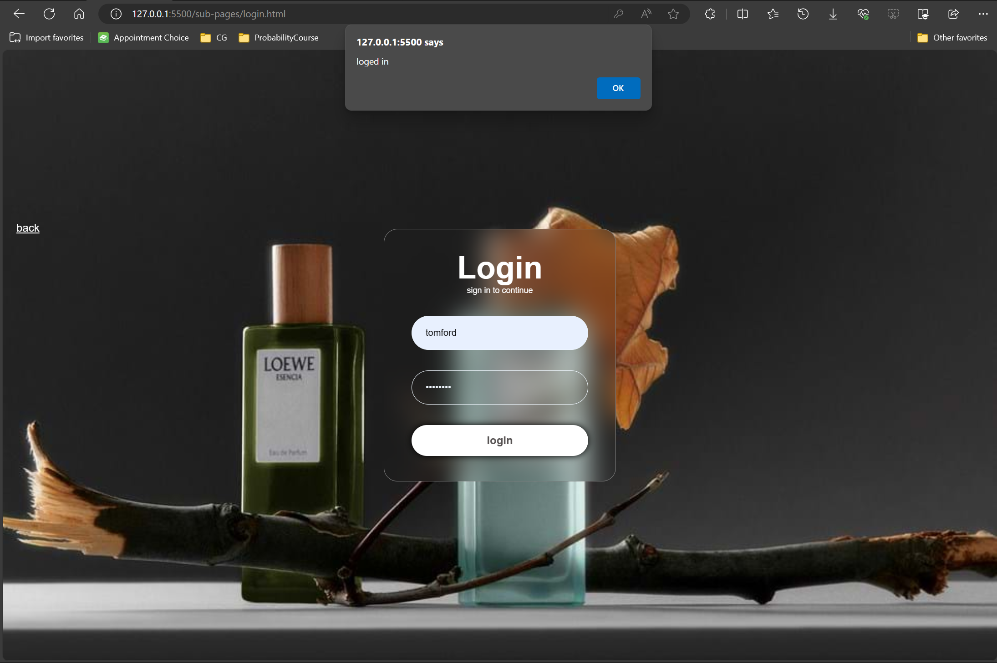

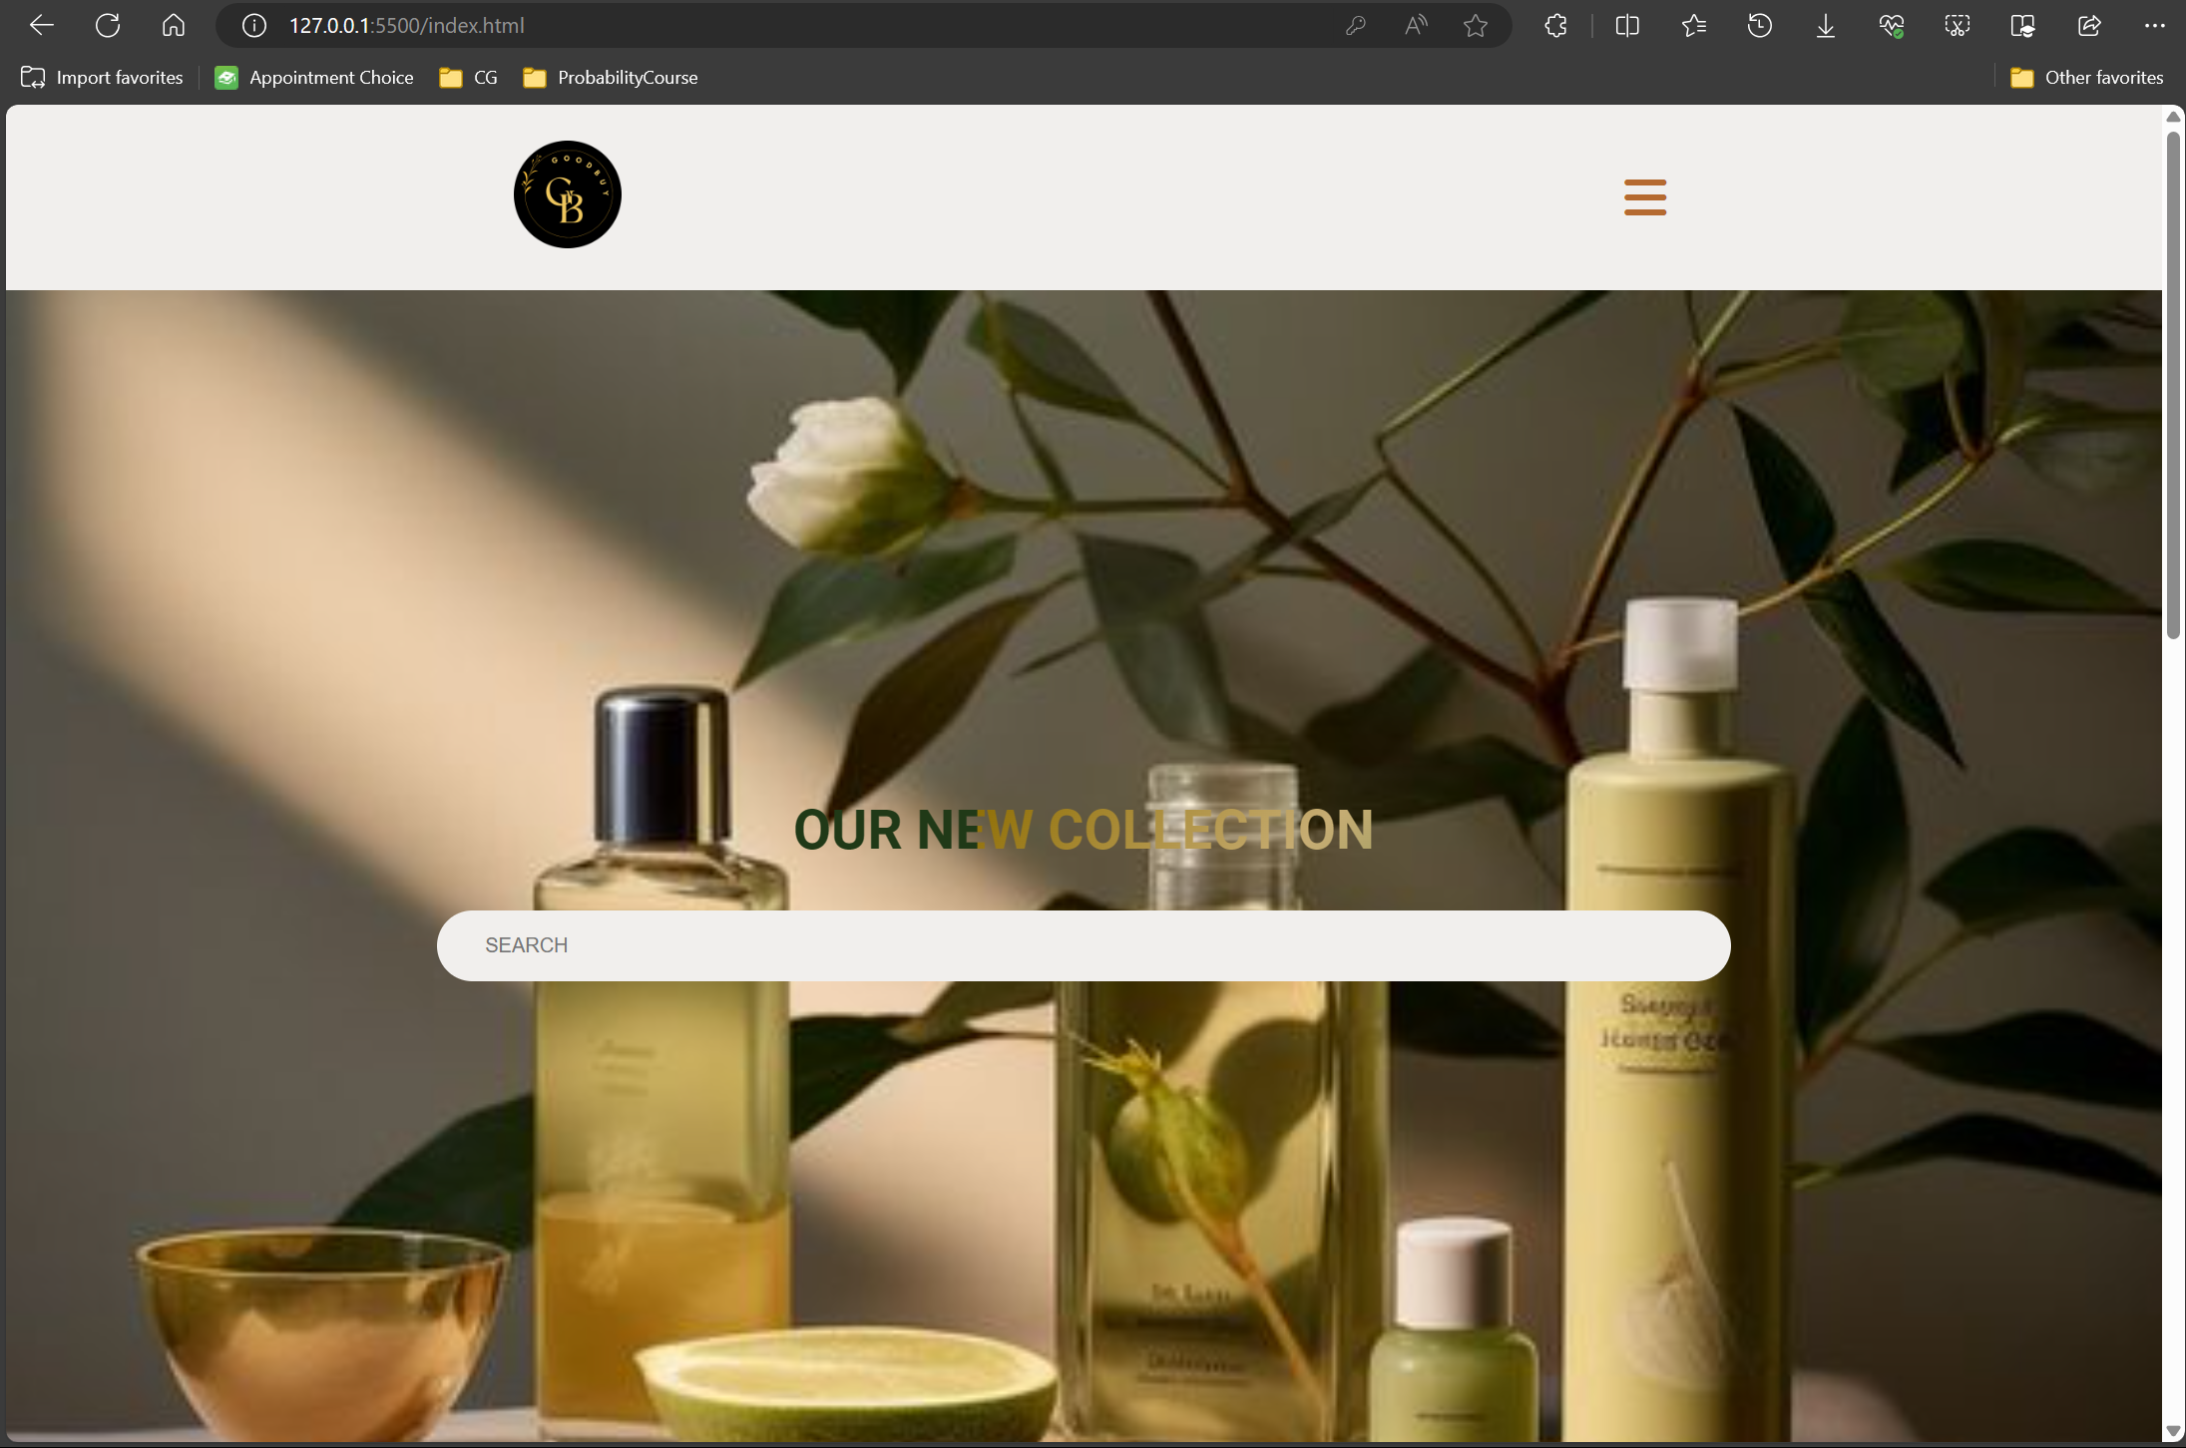

### Use case 2

### Do a search in which there is no available item

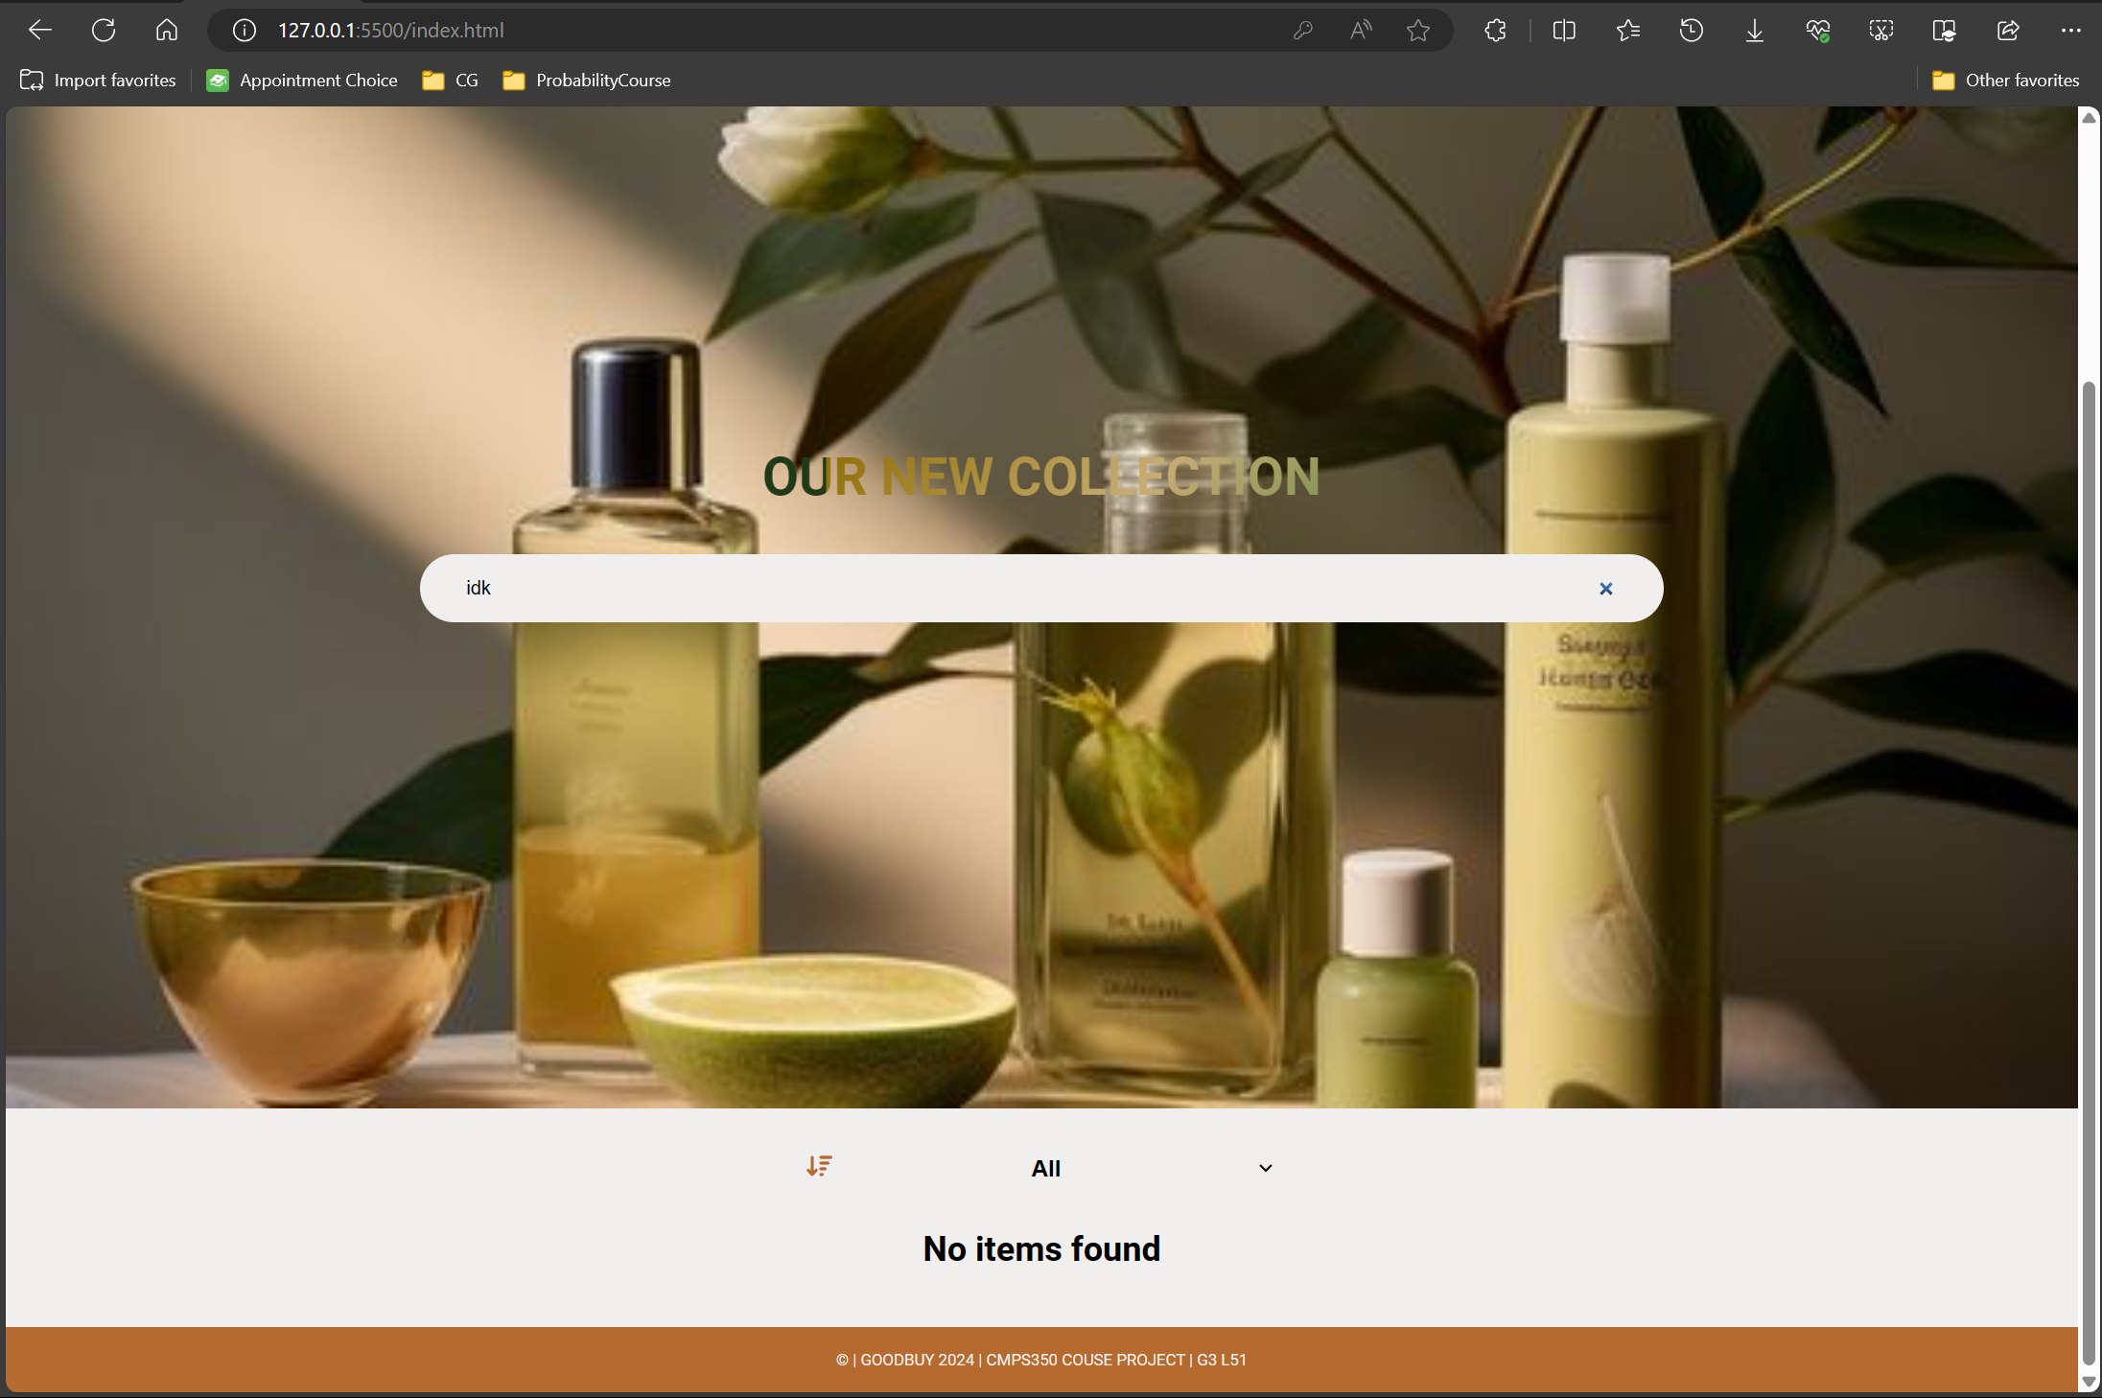

### Do a search in which there are some available items

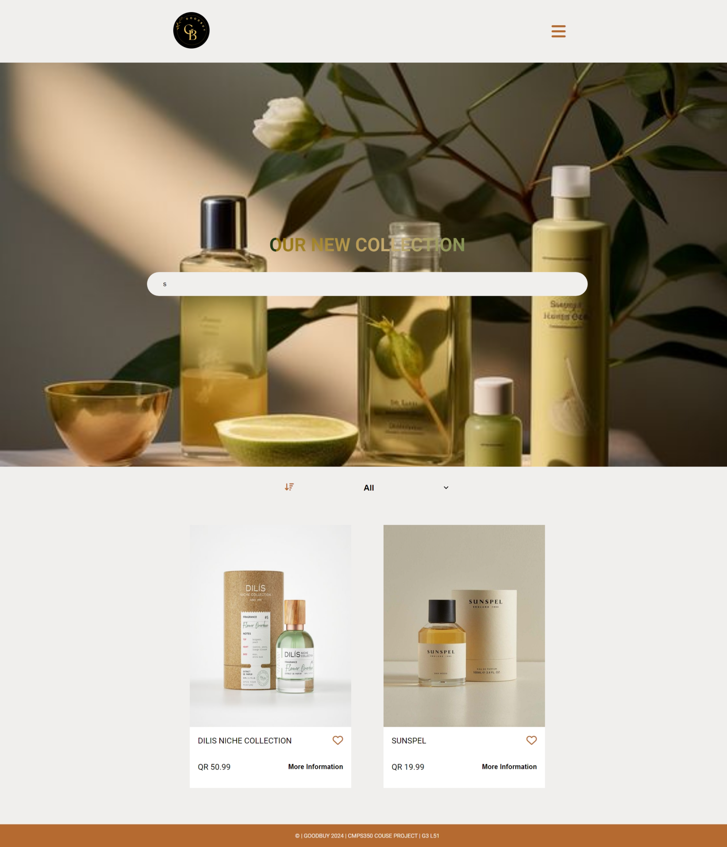

### Do another search in which there are some available items

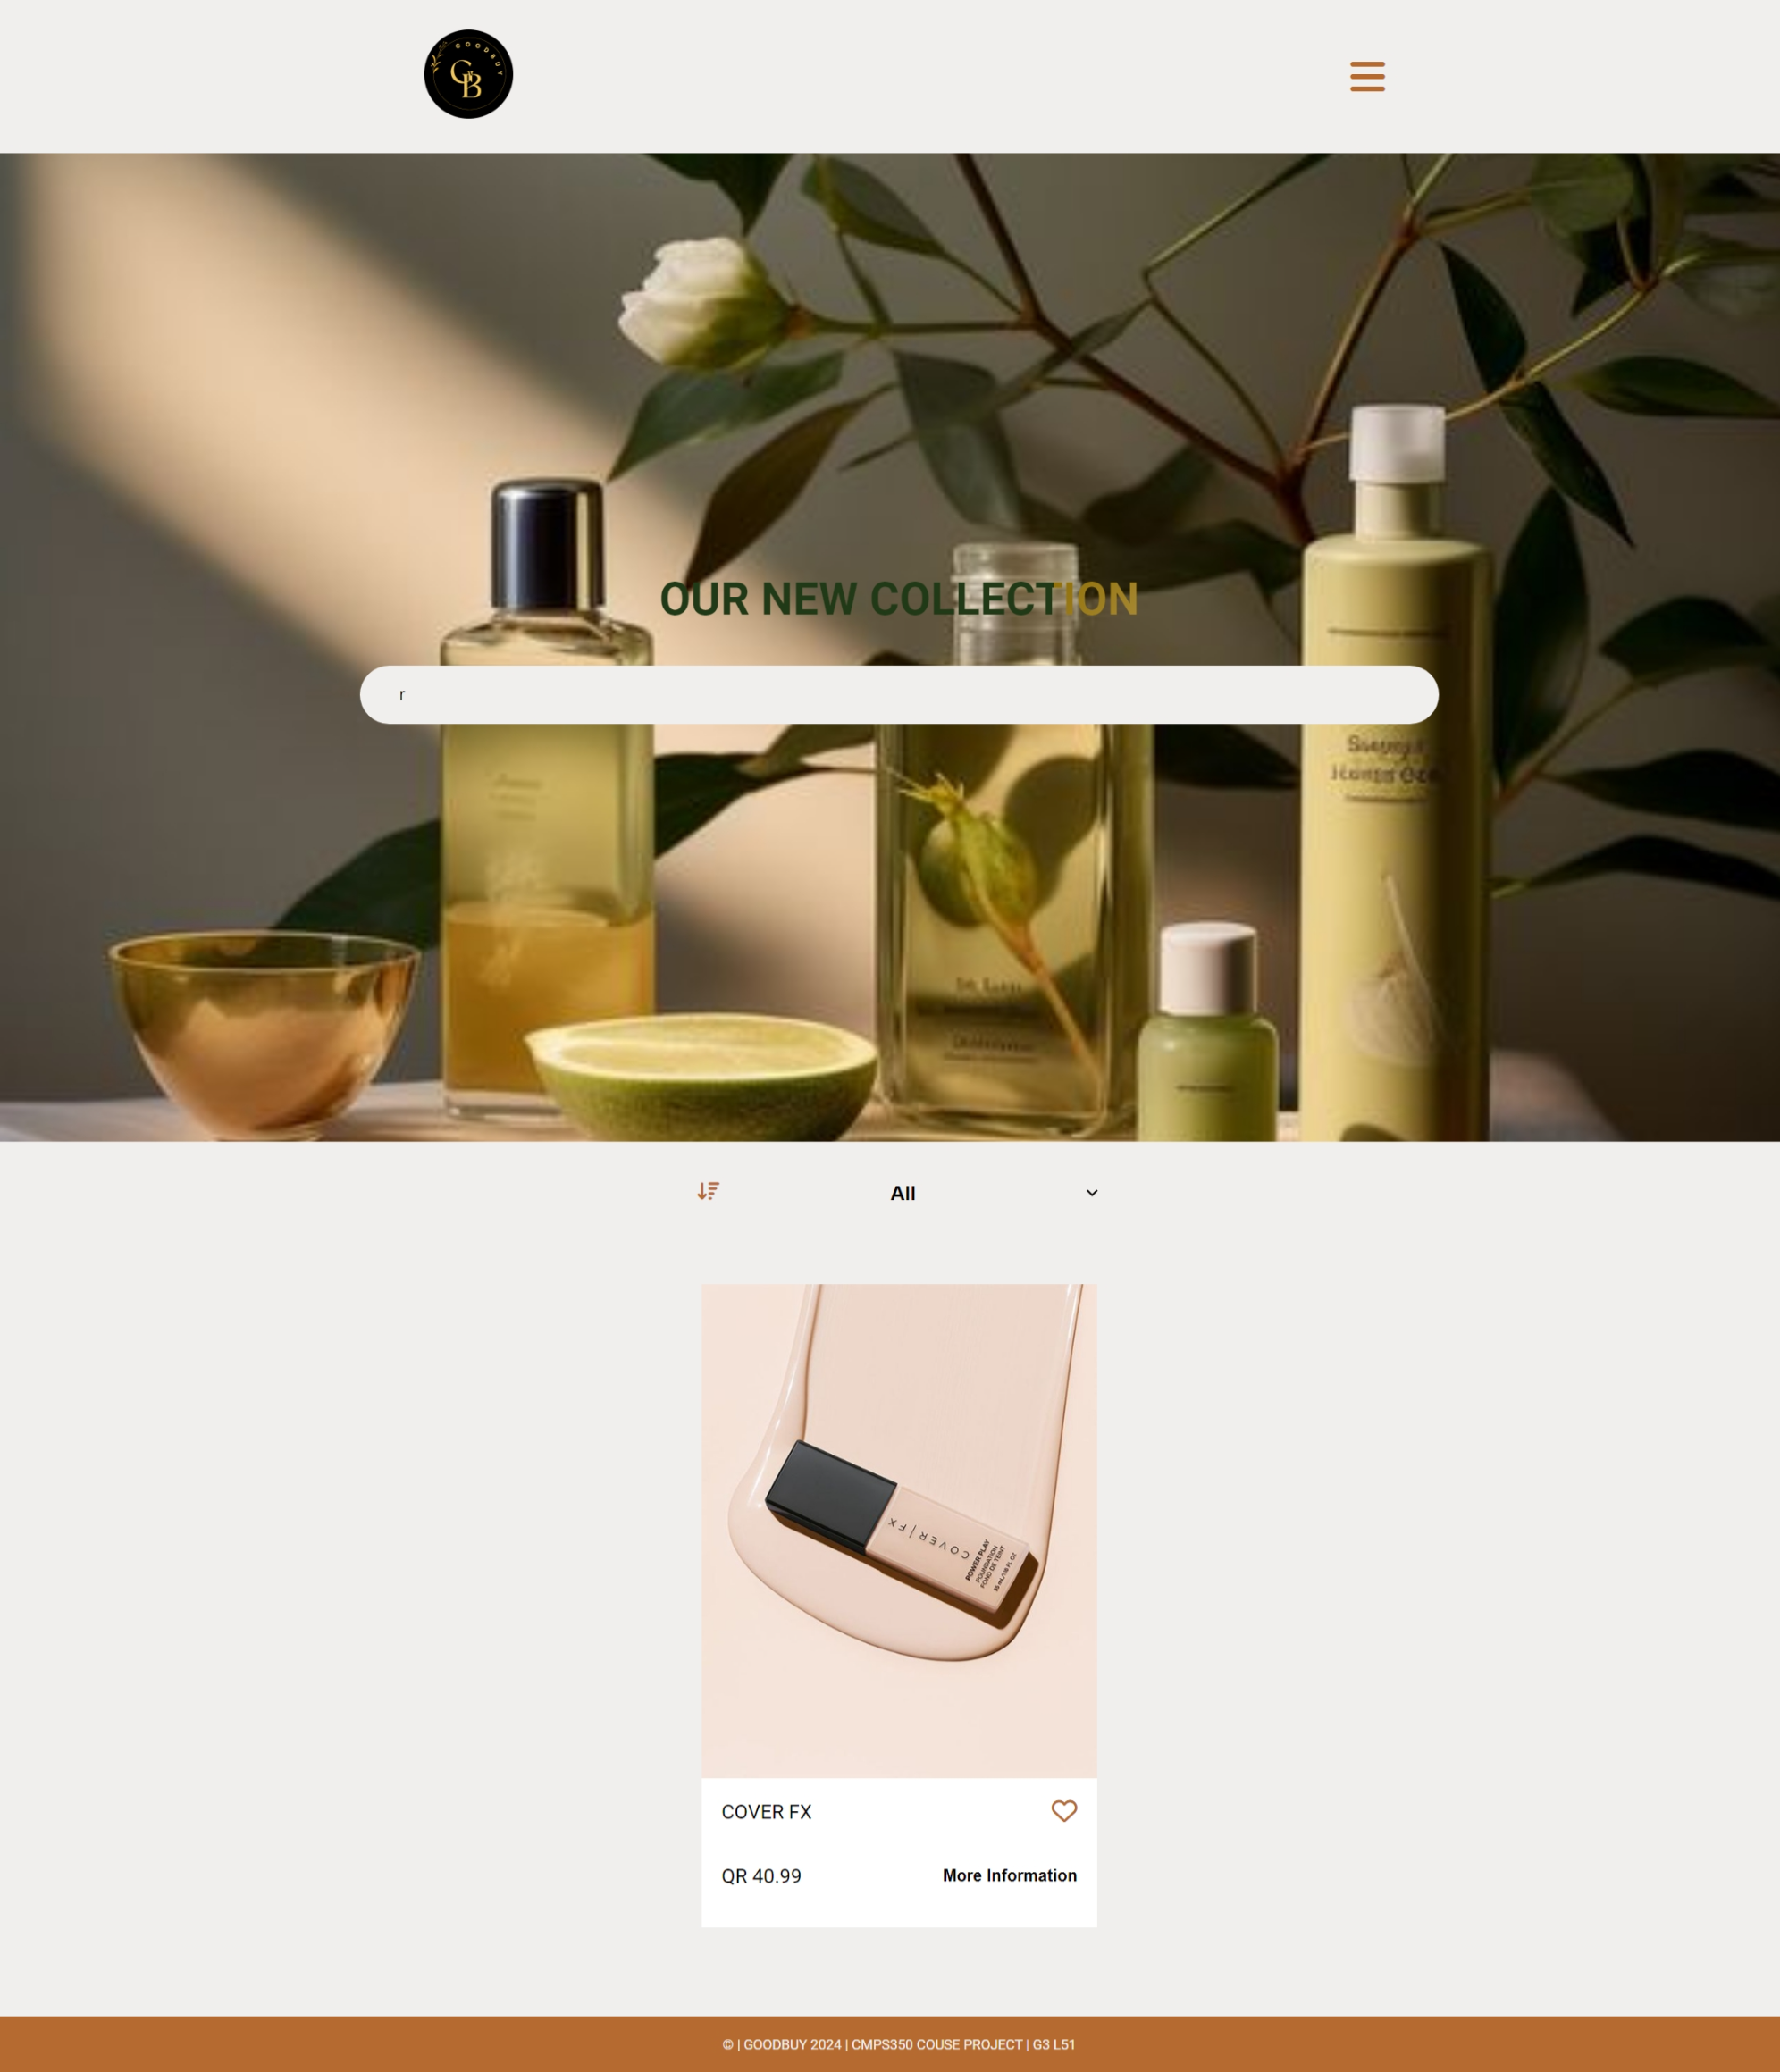

### Use case 3 and Use Case 4

### Try to purchase an item when you are not logged in (it should fail)

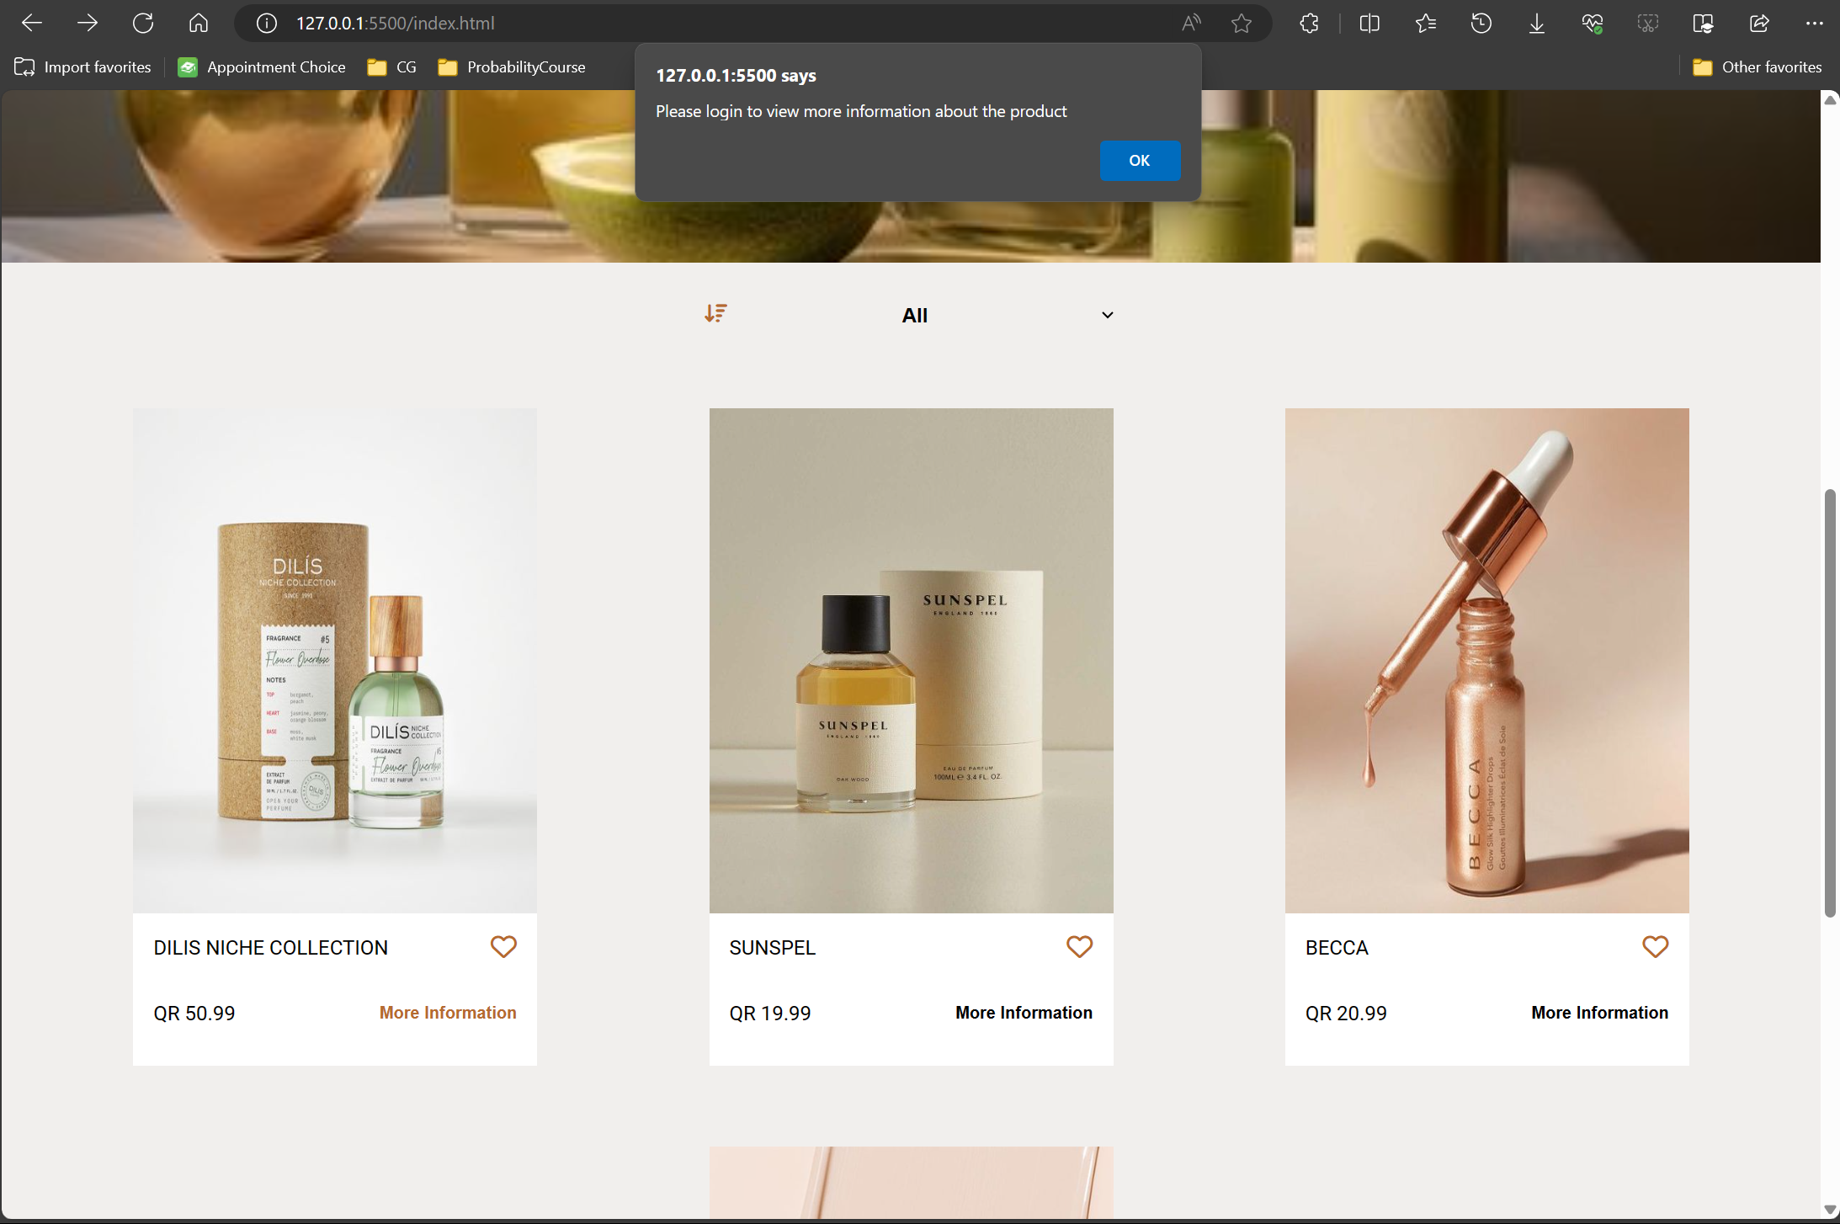

### Try to purchase an expensive item that the user does not have enough money (it should fail)

### Purchase an item successfully

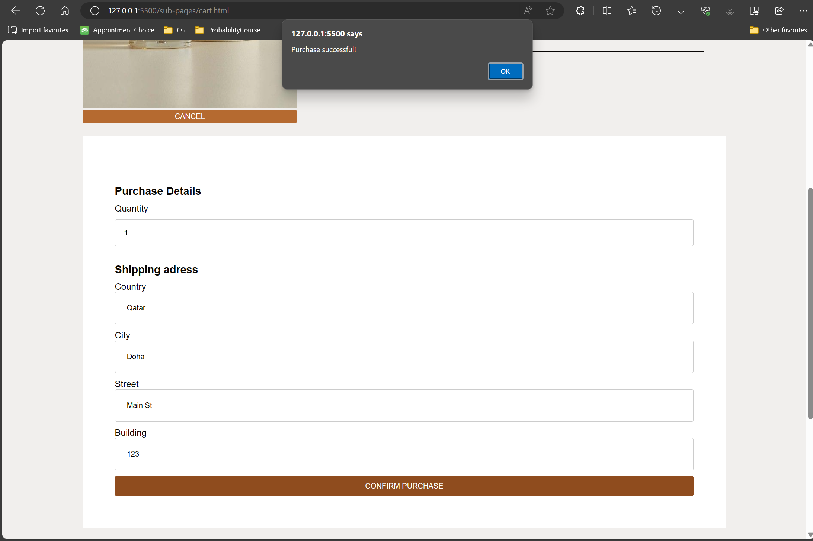

### Go to the purchase history and show that item has been bought

### Use case 5 & 6

### Upload an item to be sold

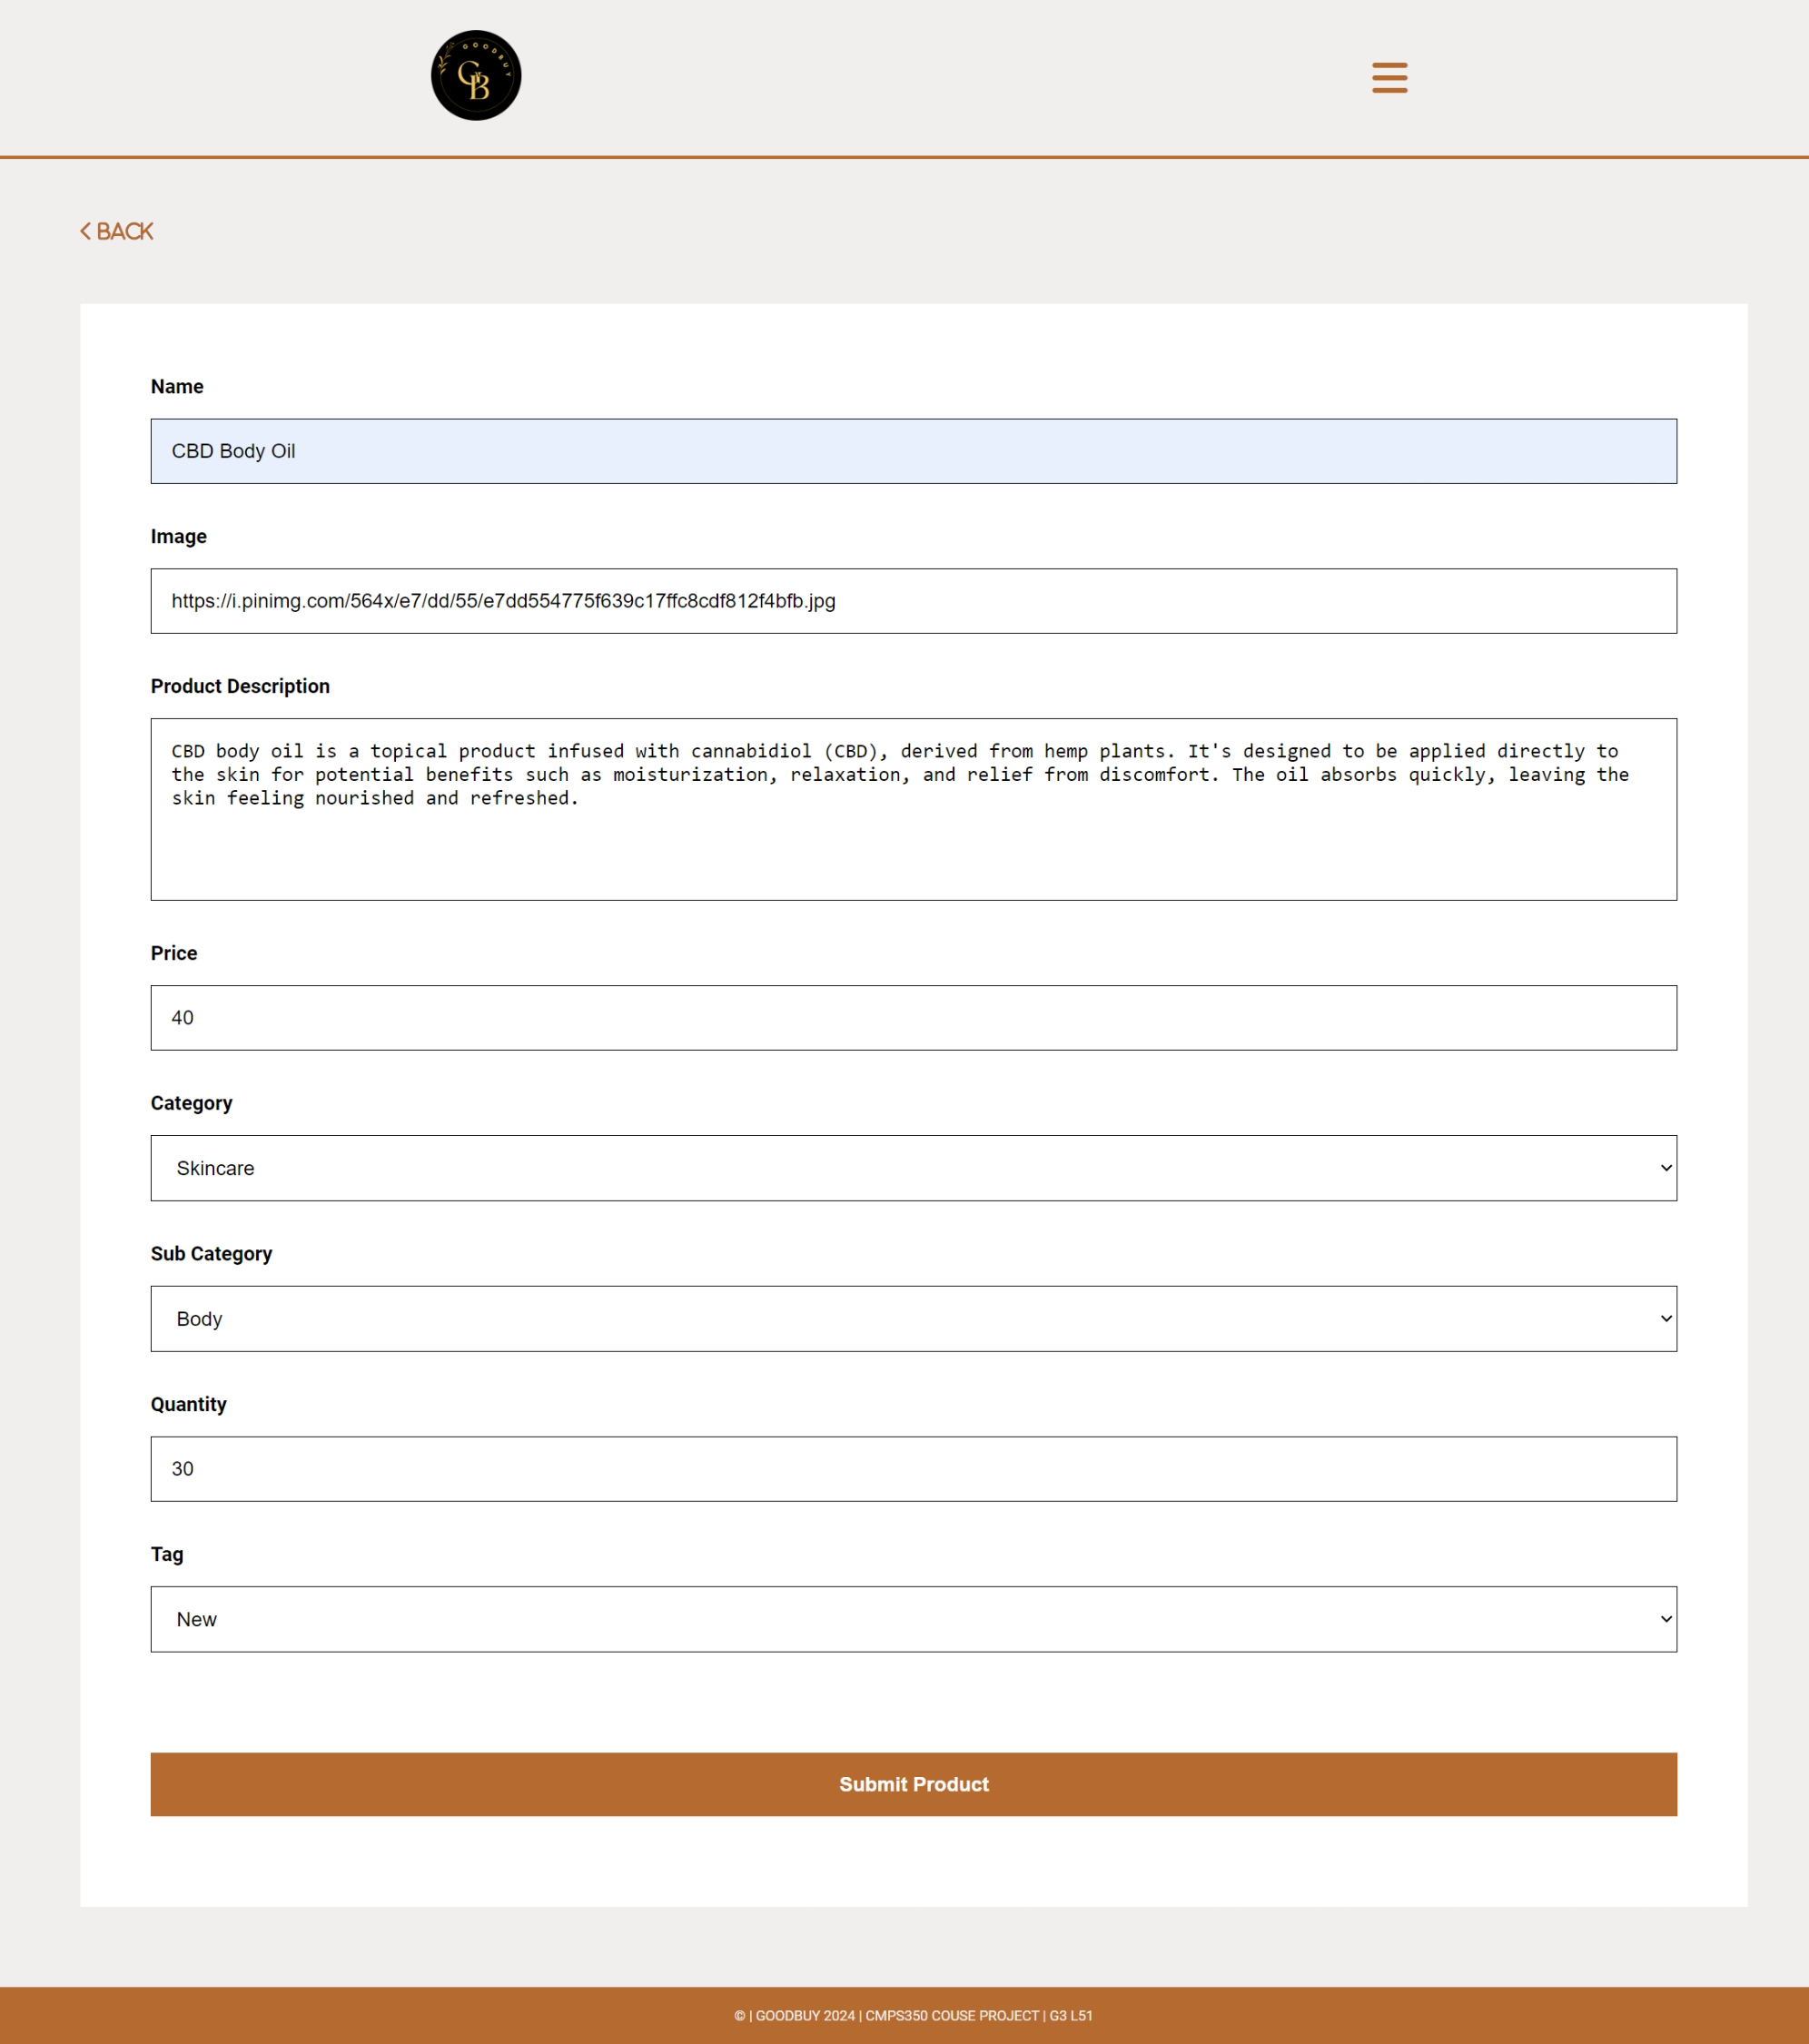

### Show that the uploaded item is now searchable

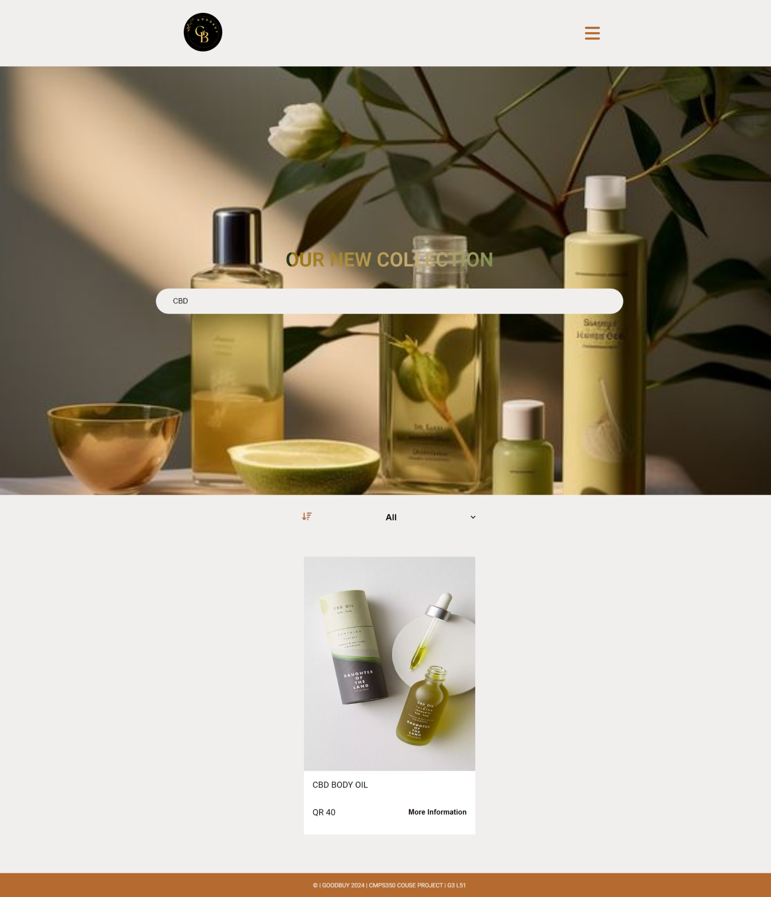

### Show that the uploaded item is on available item lists

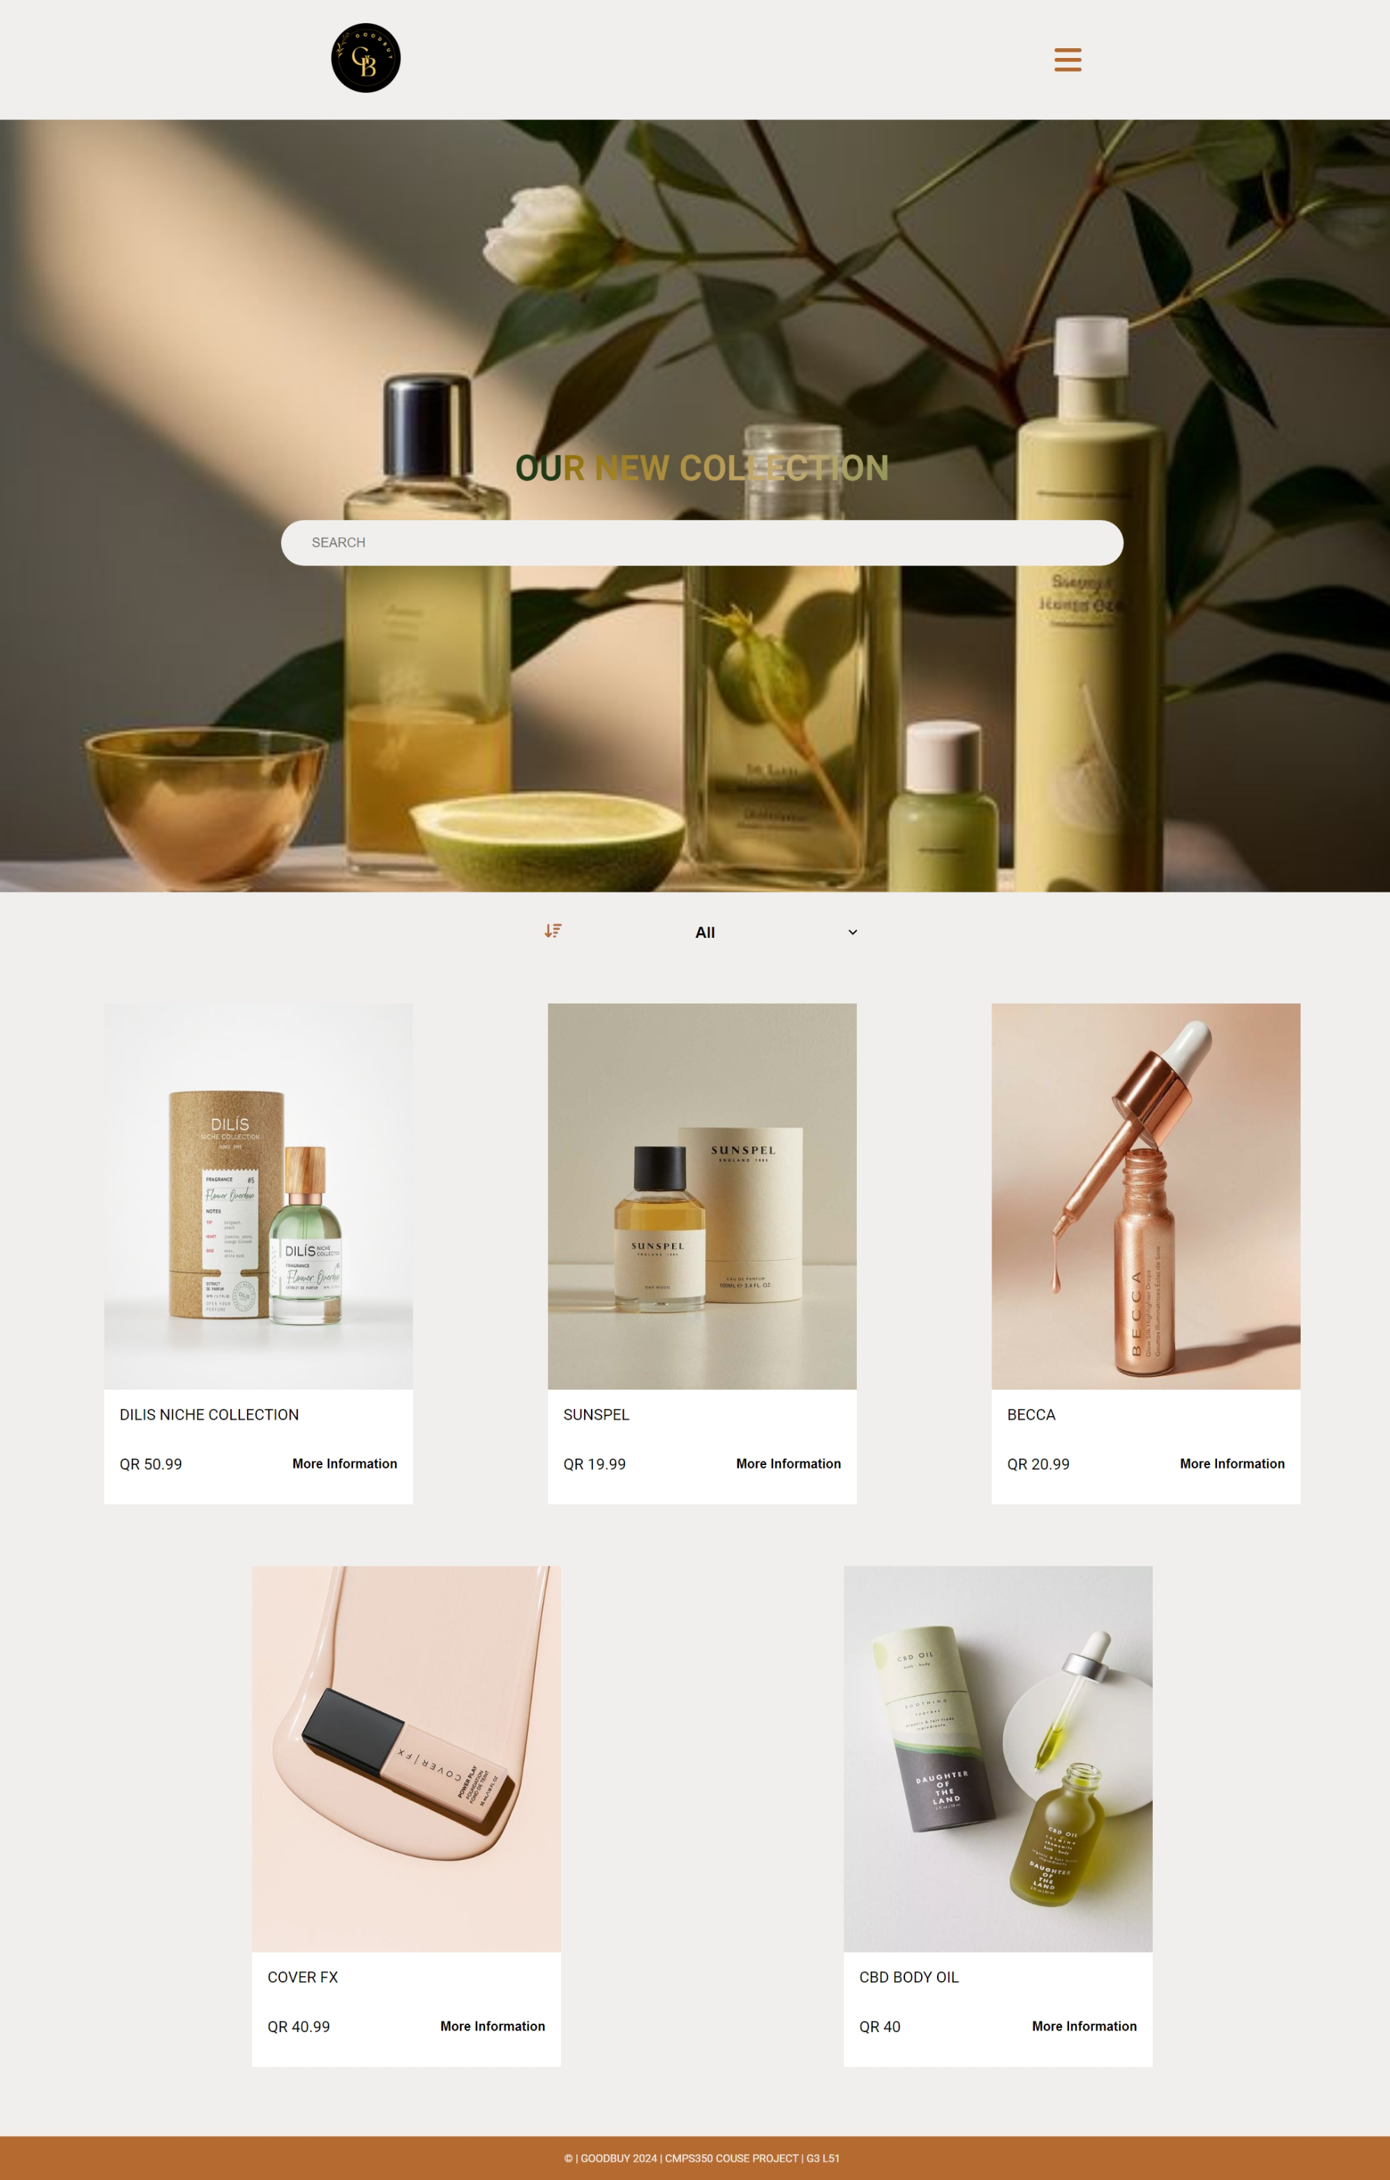

### Show that when an item is sold, its quantity decreases